## **Test Plan**

|  |  |  |  |  |
| --- | --- | --- | --- | --- |
| **Test Case Number** | **Test Description** | **Expected Result** | **Actual Result** | **Pass/Fail** |
| 1 | Startup of application | GUI in ready state with no unexpected hardware issues or system failure. | Game starts immediately | Pass |
| 2 | User initiated termination of application | Program terminated and all items are deconstructed. | The APP ends by closing window | Pass |
| 3 | User maneuvers the snake using keys on their keyboard (←, ↑, →, ↓). | Snake moves up using the ↑ arrow, down using the ↓, left using the ←, and right using the → arrow on the keyboard. | Snake moves up, down, left, and right using the following keys on the keyboard. ((←, ↑, →, ↓) | Pass |
| 4 | user maneuver the snake to consume apples | Apple is consumed and the snake length increase by one dot. | Apple is consumed and the snake length increase by one dot and new apple is generated in a different location. | Pass |
| 5 | Troubleshooting: triggering a “Game Over” with snake consuming itself | “Game Over” is triggered when snake consumes itself | “Game Over” appears and the game will need to be relaunched to play again. | Pass |

**User Guide: Operation**

1. Select “Snake” from the menu to lunch the game.

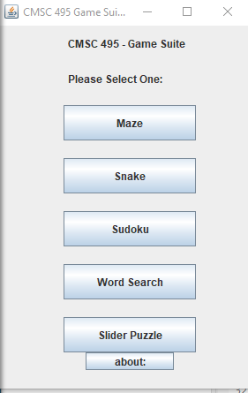

1. The game starts immediately:

* The user will maneuver the snake to eat the apples
* The user maneuvers the snake using the following keys on their keyboard (←, ↑, →, ↓).

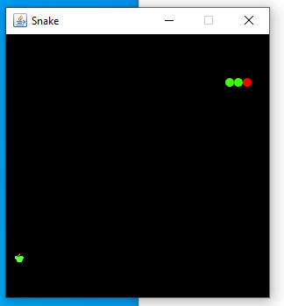

1. The game will end when the snake consumes itself.

* Game will need to be relaunched to play again.

